**DSP Assignment -3**

**Footnote 4:**

When the form of signal and system is different, how do we integrate them to work together.

**My Opinion/ view on the topic:-**

Before discussing the inter-relation, physical processes involved behind formulating Dirac function, step, ramp and parabolic manifestations, I would like to start with what exactly have we covered from the past classes.

After understanding the different types of signals whether it be continuous, discrete or digital signal, we moved forward to see what a system is and why do we use it, we then decided to move forward with the 4th footnote which deals with the question **of how to integrate a system and signal of different types so that they can work together.**

**Ways to do it:-**

* One way to do so is to convert the signal or the system to the type of the other, but this is not always feasible or rather possible and may even cause data loss in some cases.
* Ultimately, as we moved on to other way of doing it, we observed was if we send some test signals, namely:

**1.)Impulse;   
2.)Step and;   
3.)Ramp signal;** to the systems and observe the output we receive so that we can detect the type of the system and can understand the working of the same.

**The example that we discussed in the class:**

1. **Impulse Response:**

The example we used to understand these different types of signals was when we unexpectedly poke someone with a needle, the expression we receive from them is because they experience pain in a very short period of time, this poking of needed is called an impulse input and the output we receive is called impulse response of the system. Hence, we came up with the Dirac equation which defines impulse response as

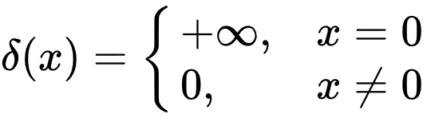

Impulse Response

1. **Step Response:**

Similarly for step signal we tried to carry forward the same example, if instead of poking someone for an instant, we keep the needle in its place while exerting constant pressure for some time, the person will stop reacting in the impulsive way as they will feel less but constant pain now, this is called the step response of a system and for ramp signal,

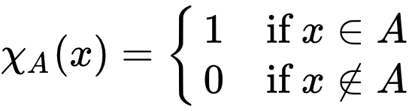

Step Response

1. **Ramp Response**

Imagine poking for a long time but we keep on increasing the pressure we exert with time, this will lead to increase in pain with time as well, this is known as the ramp response of a system.

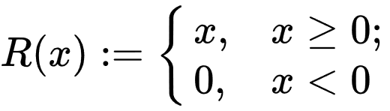

Ramp Response

**An example from my real life experience:-**

Lets take a car or a bike into consideration.

* To start the car/bike (i.e. the engine) we first have to give an ignition spark to the engine, which exists for a moment only, this can be termed as the impulse response for the engine. At this time the car starts suddenly because of an impulse response.
* Now, as the car is in the motion, we change the gear to 1st from its neutral position.  
  Now, suppose we start shifting the gear and the car goes to 2nd and then the 3rd and ultimately till the 6th gear. The torque and rpm for each gear is different. The speed varies accordingly.   
  This is the step signal that we are providing to the car engine. The speed of the car varies with shifting of each gear.
* Now, suppose we press the throttle of our car linearly (i.e. the engine does give out a sudden torque, and the acceleration is linear). Once we press the accelerator the car increases its speed (its’s output) with time, this is the ramp response for our system of a car engine.